**GITHUB Basic KT**

**Agenda-**

**1)Why we use GitHub?**

**2)What is GitHub?**

**3)Different between Git and GitHub/Working**

**4)How to use GitHub**

**5)How to create Repository**

**6)How to create Branch**

**7)Making a Commit**

**8)Pull Request**

**\*What is the need of GitHub-**

1)It is important for developers, who works on web-based platform to collaborate with other developer and share their project.

2)It enables multiple people to work simultaneously on single project.

3) We can download project and files in one go.

4)We can evaluate each other work easily.

**\*What is GitHub-**

1)Web-based git repository hosting service.

2)Easy management of code.

3)Open-source software.

4)Team collaboration.

5)Bug-Tracker (Issues).

**GitHub is popular due to-**

Popular Community, it is largest shared repository, easy version control, secured cloud storage.

**\*Different between Git and GitHub-**

**\*Git**

-It is a tool which is stored in local System.

-It is used to manage source code history.

**\*GitHub-**

-GitHub is the hosting service for git repository.

-It is a cloud-based service.

**Working of Git and GitHub-**

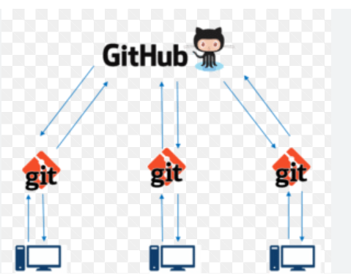

**-Git Pushes and pulls data from the central service.**

**-GitHub is a service that allows you to host a central repository in a remote service.**

**\*How to use GitHub-**

Sign in/Sign up GitHub link**-** [**https://github.com/**](https://github.com/)

**Home page**

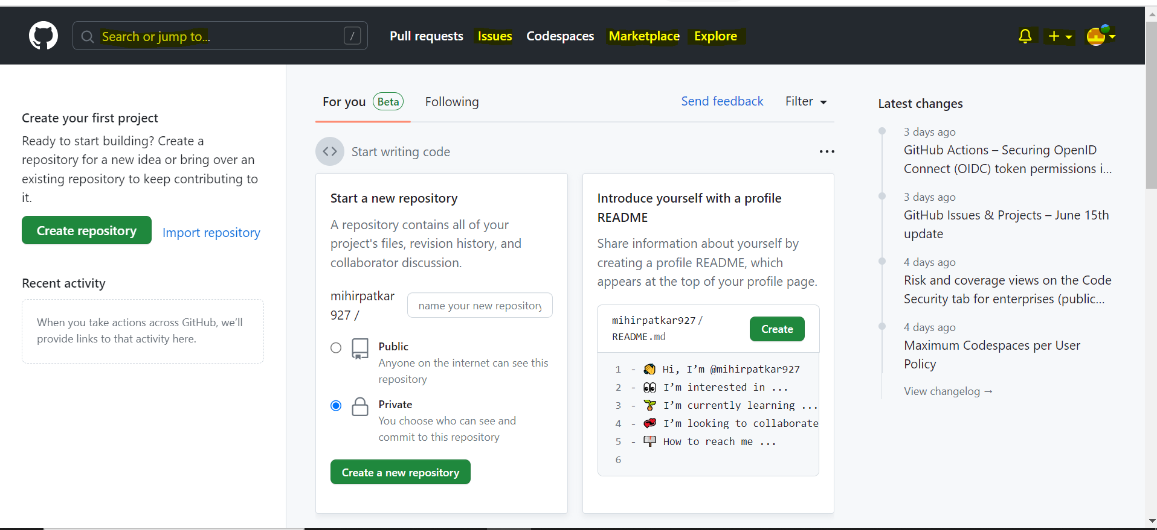

**Search Bar-**

It allows us to look for certain profiles, keywords, project that are present in GitHub.

**Issues-**

It let us to track our work on GitHub.

To indicate that work is in progress we can link an issue to a pull request.

**Explore-**

Here we can see the trending things that are ongoing on GitHub and many other things with respect to GitHub.

**Marketplace-**

Here we can share our apps and action publicly with all GitHub users.

**\*Creation of Repository**

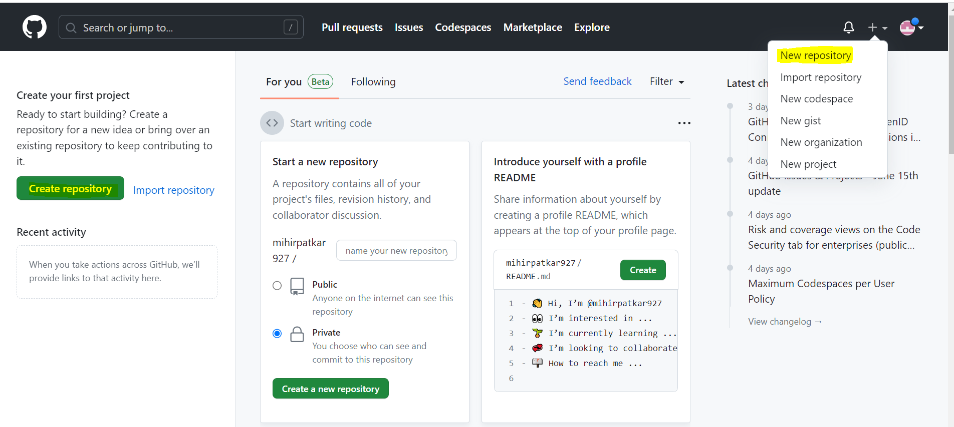

**Create Repository-Add name/Description-Set public/private-Hit create.**

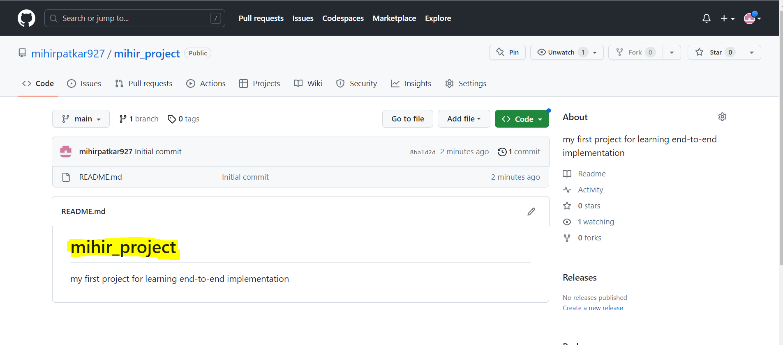

New repository is created successfully.

**<>Code**

**I**t is important as we can copy the http link and download the entire repository on local system.

**\*How to create a Branch**

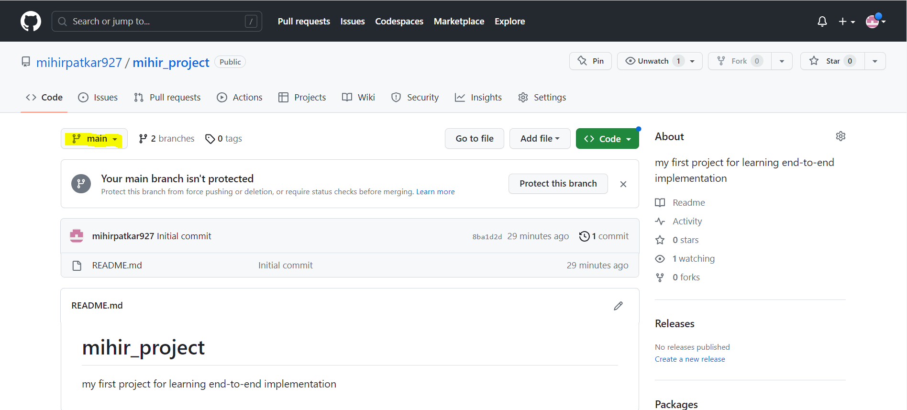

Click on highlighted item-View all branch-new branch-Name it and hit create.

Replica of main branch will be created, and we can work on different things on that branch and if happy can merge with main branch.

**\*Making a Commit**

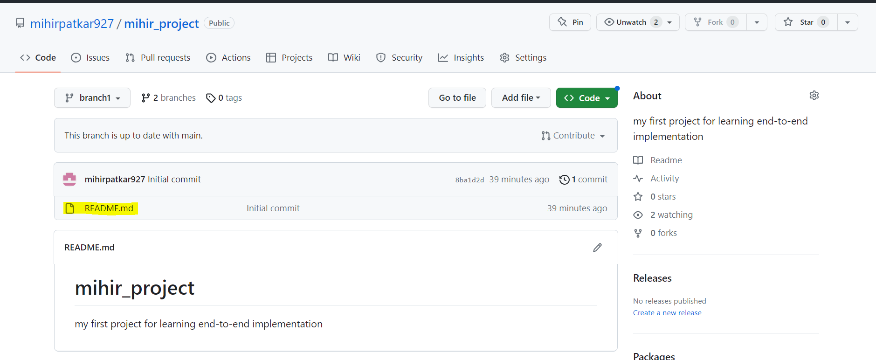

Select the file which you want to make changes

Click on pencil icon once the file is open.

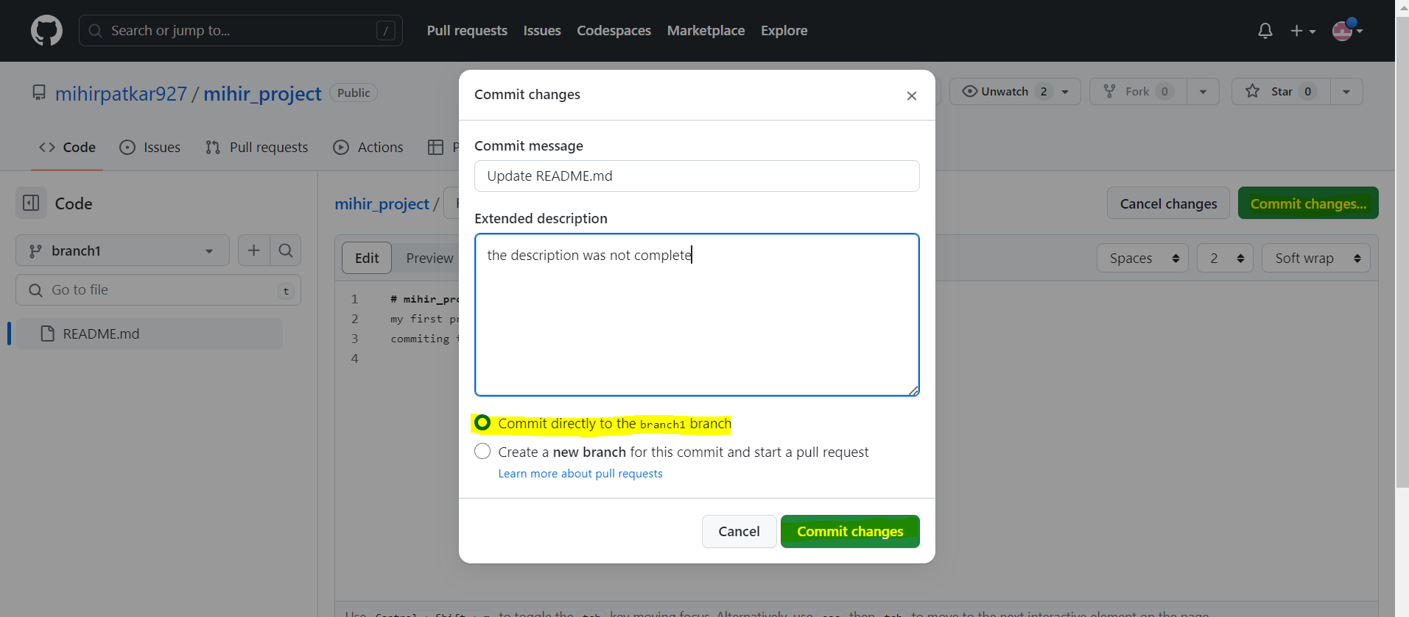

Make the changes you want-click on comment changes button on right corner-Add description why the changes are made as a good practice-select the option to which branch commit is performed-Hit commit changes.

History Button help us to check the history of each commit.

**\*Pull Request**

It notifies other developer about changes you’ve pushed to a branch in a repository.

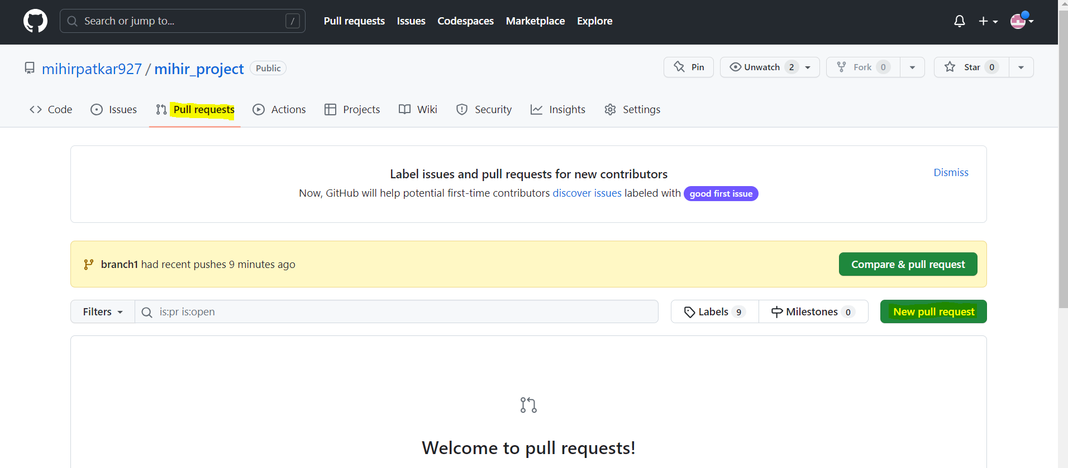

Pull Request-New Pull Request-Create Pull request – (Add description) Hit again on create pull request-Merge request.